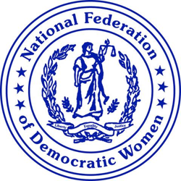

A message from NFDW President Cindy Jenks
April 21, 2021

The National Federation of Democratic Women embraces the guilty verdicts that were rendered in the trial of Derek Chauvin’s murder of George Floyd. We celebrate that justice was served at the end of this gut-wrenching trial. Before yesterday, so many times black Americans have lost their lives to excessive, and even needless, police brutality.

With this guilty on all three counts verdict, history has been made. Law enforcement leaders that testified during the trial spoke the truth rather than defending one of their own. The video recorded while former Officer Chauvin had his knee on George Floyd’s neck was made by a 17-year-old at the scene, and the video was very instrumental in helping jurors determine their verdict. The prosecution ended their case by telling the jury to “believe what your eyes saw.”

NFDW supports President Joe Biden’s statement that the verdict in the murder of George Floyd is, a “giant step forward in the march toward justice in America.”

Immediate reform of police policies and practices is imperative. Increased education directed at ending systemic racism is critical. We must work together to make our country what it was intended to be: a place of Liberty and Justice for All. Equality and opportunity for everyone.

Yours in solidarity,
Cindy Jenks, President

